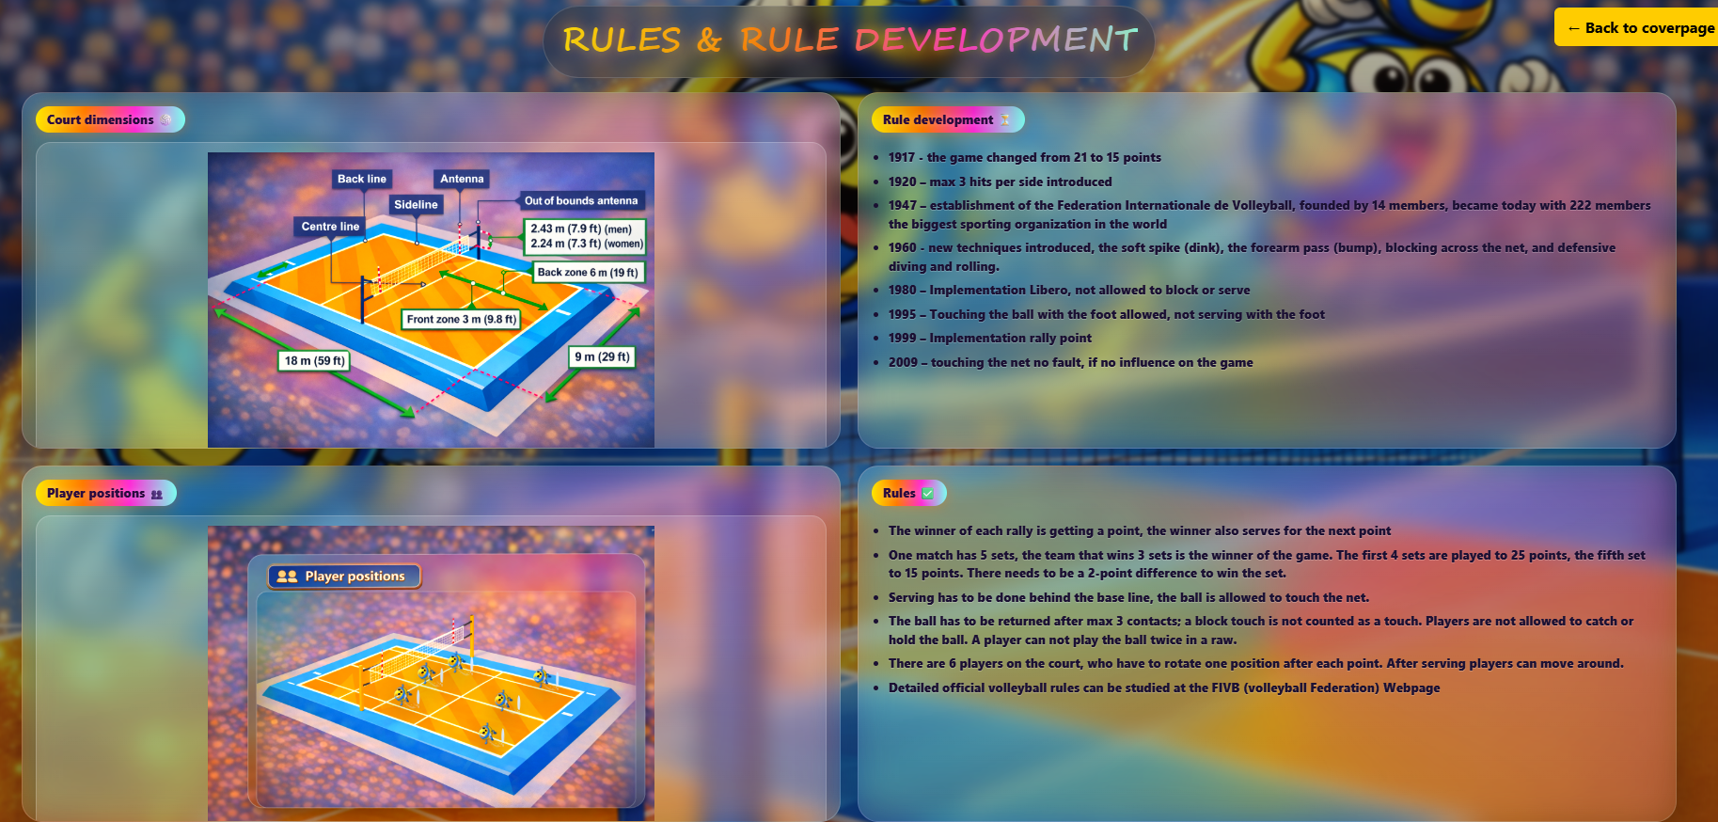
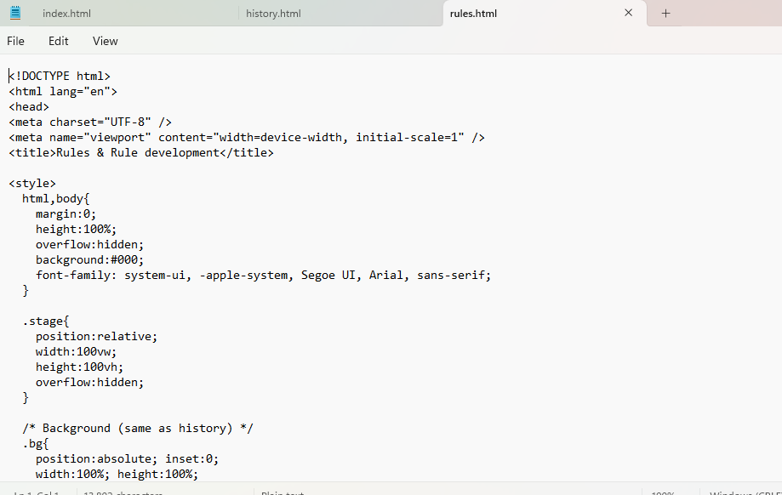

Subpage “rules/html”
Code subpage “rules.html”, notepad
<!DOCTYPE html>
<html lang="en">
<head>
<meta charset="UTF-8" />
<meta name="viewport" content="width=device-width, initial-scale=1" />
<title>Rules & Rule development</title>

<style>
html,body{
margin:0;
height:100%;
overflow:hidden;
background:#000;
font-family: system-ui, -apple-system, Segoe UI, Arial, sans-serif;
}

.stage{
position:relative;
width:100vw;
height:100vh;
overflow:hidden;
}

/* Background (same as history) */
.bg{
position:absolute; inset:0;
width:100%; height:100%;
object-fit:cover;
transform:scale(1.02);
transition:filter 1.2s ease, opacity 1.2s ease;
user-select:none; pointer-events:none;
opacity:1;
z-index:1;
}
.veil{
position:absolute; inset:0;
background:radial-gradient(circle at 50% 35%, rgba(0,0,0,.00), rgba(0,0,0,.22));
opacity:0;
transition:opacity 1.2s ease;
pointer-events:none;
z-index:2;
}

/* Title (same as history) */
.titleWrap{
position:fixed;
top:18px;
left:50%;
transform:translateX(-50%);
z-index:2147483000;
width:min(1100px, 94vw);
display:flex;
justify-content:center;
pointer-events:none;
}
.title{
margin:0;
padding:10px 18px;
border-radius:999px;
background:rgba(0,0,0,.22);
border:1px solid rgba(255,255,255,.14);
backdrop-filter: blur(10px);
box-shadow:0 18px 46px rgba(0,0,0,.25);
font-family: "Segoe Script","Comic Sans MS","Brush Script MT","Trebuchet MS",system-ui,sans-serif;
font-weight: 700;
letter-spacing: .6px;
text-transform: uppercase;
font-size:clamp(18px, 2.5vw, 34px);
}
.title span{
background: linear-gradient(90deg, #ffe600 0%, #ff7a00 35%, #ff2bd6 70%, #7cffef 100%);
-webkit-background-clip:text;
background-clip:text;
color:transparent;
text-shadow:
0 0 10px rgba(255,230,0,.35),
0 0 18px rgba(255,50,214,.25),
0 10px 30px rgba(0,0,0,.35);
}
.caret{
display:inline-block;
width:10px;
margin-left:6px;
border-right:3px solid rgba(255,230,0,.85);
transform: translateY(2px);
animation: blink 800ms steps(1) infinite;
}
@keyframes blink{ 50%{opacity:0;} }

/* Grid */
.grid{
position:absolute;
inset:0;
z-index:5;
padding:110px 4vw 28px 4vw;
display:grid;
grid-template-columns: 1fr 1fr;
grid-template-rows: 1fr 1fr;
gap:18px;
align-items:stretch;
}

/* Cards */
.card{
position:relative;
border-radius:22px;
overflow:hidden;
background: linear-gradient(180deg, rgba(255,255,255,.16), rgba(255,255,255,.08));
border:1px solid rgba(255,255,255,.18);
backdrop-filter: blur(12px);
box-shadow: 0 18px 54px rgba(0,0,0,.32);

opacity:0;
transform: translateY(18px) scale(.98);
transition: opacity 700ms ease, transform 700ms cubic-bezier(.2,.9,.2,1);
}
.card.show{
opacity:1;
transform: translateY(0) scale(1);
}
.card::before{
content:"";
position:absolute; inset:-2px;
border-radius:24px;
background: conic-gradient(from 180deg,
rgba(255,210,0,.85),
rgba(0,190,255,.80),
rgba(255,60,210,.70),
rgba(255,210,0,.85)
);
filter: blur(16px);
opacity:.40;
z-index:0;
}

.cardInner{
position:relative;
z-index:1;
height:100%;
padding:14px 14px 12px 14px;
display:flex;
flex-direction:column;
gap:10px;
}

.badge{
display:inline-flex;
align-items:center;
gap:8px;
width:fit-content;
padding:6px 12px;
border-radius:999px;
background:linear-gradient(90deg,#ffe600,#ff7a00,#ff2bd6,#7cffef);
color:#2a0b3f;
text-shadow:0 0 6px rgba(255,255,255,.35);
font-weight:900;
font-size:12.5px;
letter-spacing:.35px;
box-shadow:0 0 14px rgba(255,122,0,.45);
}

/* Text NOT white */
.text{
color:#1b1033;
font-weight:800;
font-size:13px;
line-height:1.5;
text-shadow: 0 1px 0 rgba(255,255,255,.22);
}
.text ul{ margin:0; padding-left:18px; }
.text li{ margin:6px 0; }

/* Frames */
.imgFrame{
flex:1;
min-height:220px;
border-radius:16px;
border:1px solid rgba(0,0,0,.08);
box-shadow: 0 14px 34px rgba(0,0,0,.18);
padding:10px;
display:flex;
align-items:center;
justify-content:center;
overflow:hidden;
}

/* Glass background (same look as Player positions) */
.imgFrame.clear{
background: rgba(255,255,255,.12);
border: 1px solid rgba(255,255,255,.20);
}
.imgFrame.glass{
background: rgba(255,255,255,.12);
border: 1px solid rgba(255,255,255,.20);
}

.imgFrame img{
width:100%;
height:100%;
object-fit:contain;
display:block;
filter: saturate(1.25) contrast(1.10) brightness(1.03);
}

/* Player overlay */
.posWrap{
position:relative;
width:100%;
height:100%;
}
.posBase{
width:100%;
height:100%;
object-fit:contain;
display:block;
}

/* ==========================================
Players (bigger + rotated 90° left)
========================================== */
.player{
position:absolute;
width:clamp(22px, 2.4vw, 44px); /* bigger players */
aspect-ratio: 1 / 1;
transform: translate(-50%, -85%);
transform-origin: 50% 100%;
cursor:pointer;
pointer-events:auto;
z-index: 5;
filter: drop-shadow(0 10px 10px rgba(0,0,0,.28));
}

.player img{
width:100%;
height:100%;
display:block;
user-select:none;
-webkit-user-drag:none;

/* rotate player 90° to the left */
transform: rotate(-90deg);
transform-origin: 50% 50%;
}

.player .label{
position:absolute;
left:50%;
top:120%;
transform:translateX(-50%);
white-space:nowrap;
font-size:10.5px;
font-weight:900;
padding:4px 8px;
border-radius:999px;
background:rgba(10,20,40,.82);
color:#fff;
opacity:0;
pointer-events:none;
transition: opacity .15s ease, transform .15s ease;
}
.player:hover .label{
opacity:1;
transform:translateX(-50%) translateY(2px);
}

@keyframes hoverJump{
0% { transform: translate(-50%, -85%) translateY(0) scale(1); }
25% { transform: translate(-50%, -85%) translateY(-34px) scale(1.10); }
55% { transform: translate(-50%, -85%) translateY(-34px) scale(1.10); }
100% { transform: translate(-50%, -85%) translateY(0) scale(1); }
}
.player:hover{
animation: hoverJump .95s ease-out;
filter: drop-shadow(0 16px 14px rgba(0,0,0,.35));
}

/* Reveal */
.stage.reveal .bg{
filter: blur(2px) saturate(.92) contrast(.98);
opacity:.78;
}
.stage.reveal .veil{ opacity:1; }

.backBtn{
position:fixed;
right:20px;
top:20px;
z-index:10000;
padding:10px 15px;
background:#ffcc00;
color:#000;
font-weight:bold;
text-decoration:none;
border-radius:6px;
box-shadow: 0 2px 8px rgba(0,0,0,0.2);
}

@media (max-width: 980px){
body{ overflow:auto; }
.stage{ height:auto; min-height:100vh; overflow:visible; }
.grid{
position:relative;
padding:110px 4vw 28px 4vw;
grid-template-columns: 1fr;
grid-template-rows: auto;
}
}
</style>
</head>

<body>
<div class="stage" id="stage">
<img class="bg" src="history-bg.png" alt="bg">
<div class="veil"></div>

<div class="titleWrap">
<div class="title">
<span id="titleText"></span><span class="caret" id="caret"></span>
</div>
</div>

<div class="grid">
<!-- 1) Court dimensions (glass background like players) -->
<section class="card" id="c1">
<div class="cardInner">
<div class="badge">Court dimensions 🏐</div>
<div class="imgFrame glass">
<img id="courtImg" src="dimensions.png" alt="Court dimensions">
</div>
</div>
</section>

<!-- 2) Rule development -->
<section class="card" id="c2">
<div class="cardInner">
<div class="badge">Rule development ⏳</div>
<div class="text" style="overflow:auto; padding-right:6px;">
<ul>
<li><b>1917</b> - the game changed from 21 to 15 points</li>
<li><b>1920</b> – max 3 hits per side introduced</li>
<li><b>1947</b> – establishment of the Federation Internationale de Volleyball, founded by 14 members, became today with 222 members the biggest sporting organization in the world</li>
<li><b>1960</b> - new techniques introduced, the soft spike (dink), the forearm pass (bump), blocking across the net, and defensive diving and rolling.</li>
<li><b>1980</b> – Implementation Libero, not allowed to block or serve</li>
<li><b>1995</b> – Touching the ball with the foot allowed, not serving with the foot</li>
<li><b>1999</b> – Implementation rally point</li>
<li><b>2009</b> – touching the net no fault, if no influence on the game</li>
</ul>
</div>
</div>
</section>

<!-- 3) Player positions -->
<section class="card" id="c3">
<div class="cardInner">
<div class="badge">Player positions 👥</div>

<div class="imgFrame clear">
<div class="posWrap">
<img class="posBase" id="posImg" src="player_positions_empty.png" alt="Player positions">

<!--
✅ Moved SOUTH-WEST (left + down) so they sit in the right half orange area.
If you want even more SW: subtract ~1-2% left and add ~1% top.
-->

<!-- FRONT ROW (near net) -->
<div class="player" style="left:47%; top:62%;">
<img src="jumper.png" alt="Opposite">
<div class="label">Opposite (front left)</div>
</div>

<div class="player" style="left:50%; top:55%;">
<img src="jumper.png" alt="Middle blocker/hitter">
<div class="label">Middle blocker/hitter (front middle)</div>
</div>

<div class="player" style="left:54%; top:51%;">
<img src="jumper.png" alt="Outside hitter">
<div class="label">Outside hitter (front right)</div>
</div>

<!-- BACK ROW -->
<div class="player" style="left:58%; top:75%;">
<img src="jumper.png" alt="Outside hitter">
<div class="label">Outside hitter (back left)</div>
</div>

<div class="player" style="left:60%; top:64%;">
<img src="jumper.png" alt="Libero">
<div class="label">Libero (back middle)</div>
</div>

<div class="player" style="left:65%; top:56%;">
<img src="jumper.png" alt="Setter">
<div class="label">Setter (back right)</div>
</div>

</div>
</div>
</div>
</section>

<!-- 4) Rules -->
<section class="card" id="c4">
<div class="cardInner">
<div class="badge">Rules ✅</div>
<div class="text" style="overflow:auto; padding-right:6px;">
<ul>
<li>The winner of each rally is getting a point, the winner also serves for the next point</li>
<li>One match has 5 sets, the team that wins 3 sets is the winner of the game. The first 4 sets are played to 25 points, the fifth set to 15 points. There needs to be a 2-point difference to win the set.</li>
<li>Serving has to be done behind the base line, the ball is allowed to touch the net.</li>
<li>The ball has to be returned after max 3 contacts; a block touch is not counted as a touch. Players are not allowed to catch or hold the ball. A player can not play the ball twice in a raw.</li>
<li>There are 6 players on the court, who have to rotate one position after each point. After serving players can move around.</li>
<li>Detailed official volleyball rules can be studied at the FIVB (volleyball Federation) Webpage</li>
</ul>
</div>
</div>
</section>
</div>
</div>

<a class="backBtn" href="index.html">← Back to coverpage</a>

<script>
const stage = document.getElementById("stage");
const titleText = document.getElementById("titleText");
const caret = document.getElementById("caret");

const TITLE = "RULES & RULE DEVELOPMENT";
const TYPE_SPEED_MS = 38;

const SHOW_BG_ONLY_MS = 650;
const REVEAL_MS = 1550;

// 4 blocks one after another, 2 sec gap
const CARD_START_MS = 2400;
const CARD_GAP_MS = 2000;

function typeTitle(){
let i=0;
(function tick(){
titleText.textContent = TITLE.slice(0,i++);
if(i <= TITLE.length) setTimeout(tick, TYPE_SPEED_MS);
else caret.style.display = "none";
})();
}

function revealCards(){
const ids = ["c1","c2","c3","c4"];
ids.forEach((id, idx)=>{
setTimeout(()=>document.getElementById(id).classList.add("show"), CARD_START_MS + idx*CARD_GAP_MS);
});
}

// safety fallback if someone moves the files back into assets/images later
function attachFallback(imgEl, candidates){
let i = 0;
imgEl.addEventListener("error", ()=>{
i++;
if(i < candidates.length) imgEl.src = candidates[i];
});
if (candidates[0] !== imgEl.getAttribute("src")) imgEl.src = candidates[0];
}

window.addEventListener("load", ()=>{
attachFallback(document.getElementById("courtImg"), [
"dimensions.png",
"assets/images/Field_dimensions.png"
]);

attachFallback(document.getElementById("posImg"), [
"player_positions_empty.png",
"player_positions.png",
"assets/images/Player_position.png"
]);

setTimeout(typeTitle, SHOW_BG_ONLY_MS);
setTimeout(()=>stage.classList.add("reveal"), REVEAL_MS);
revealCards();
});
</script>
</body>
</html>

